**ADVANCE TASK SPRINT 4**

**20. Using Existing KeysDW, Build Monthly Property financial report on PowerBI- rental income vs expense.**

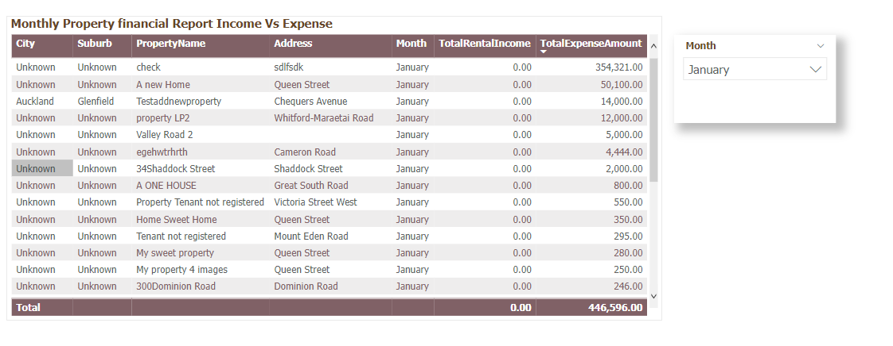

**21. Using Existing KeysDW, Line chart of Property Value Changes in the suburb of 1,5 and 10 years on DW.**

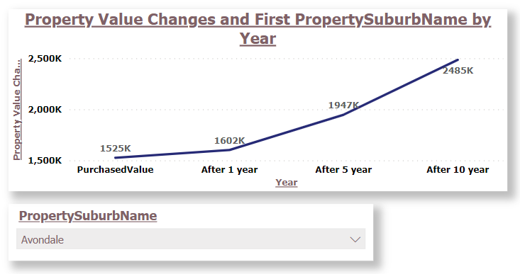

**22.** **Using Existing KeysDW, Build Pie chart of all expenses categories on DW**

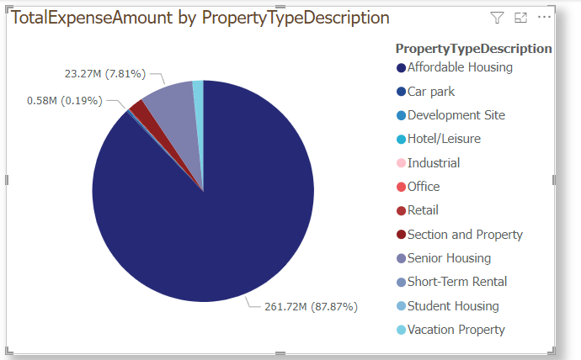

**23. Using Existing KeysDW, Build Custom map display Public transport within 1km radius of given input property**

**Final Dashboard.**

